## Restaurant Restful Application

Name :Amit Bhandari

Email :asb634@nyu.edu

I have implemented this project with almost all requirements specified in the presentation . This document will guide you to navigate through the application and features that are implemented.

**Application technologies used :**

* Frontend pages :HTML 5, bootstrap CSS and responsive design
* JavaScript : Angular.js
* Middleware : Java Restful API ,jersey and Jackson
* Backend : MySQL stored procedures

Resources :

* RestApp.war : Project files
* database.sql :Import this file into database (You may require to change database login details in DbUtils.java file which is in solutions.amit.utils package)
* Project document

**Features implemented:**

1. **Home page :**
   1. Image slider using html and css

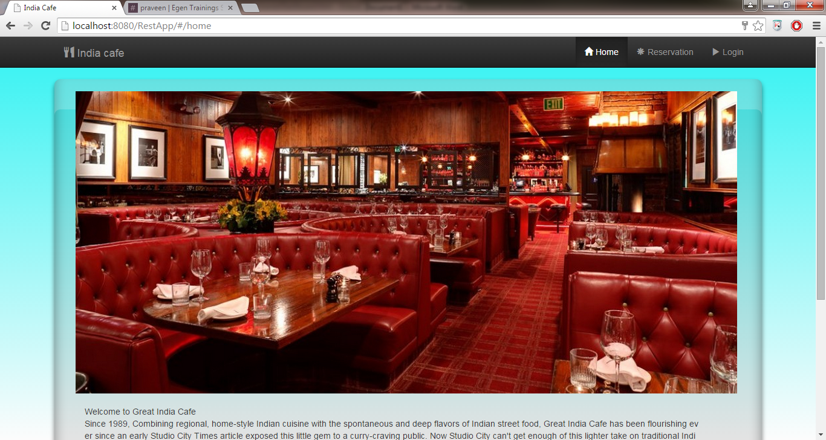 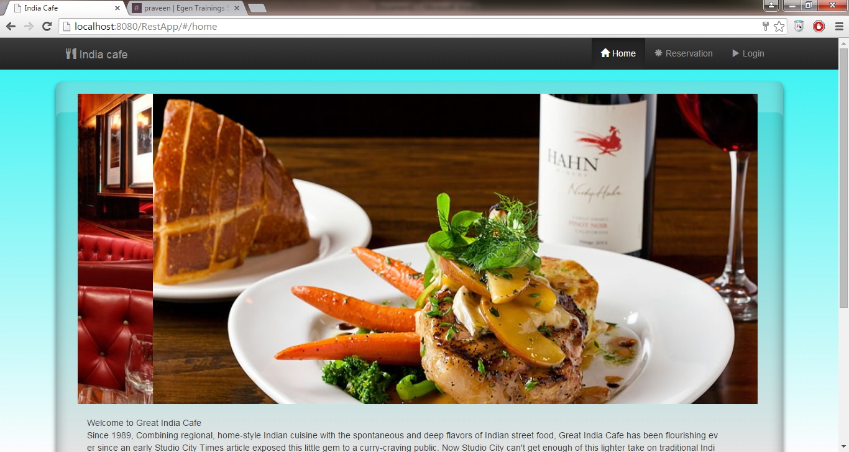

1. **Customer Reservation Page :**
   1. Implemented dynamic tab pane including functionality to create, modify or delete reservations.
   2. Data sent and received from database using angular services using model, services and factories.
   3. Implemented Logic for auto assignment of tables in Java and stored procedures MySQL
   4. Fields are validated using Angular validation.

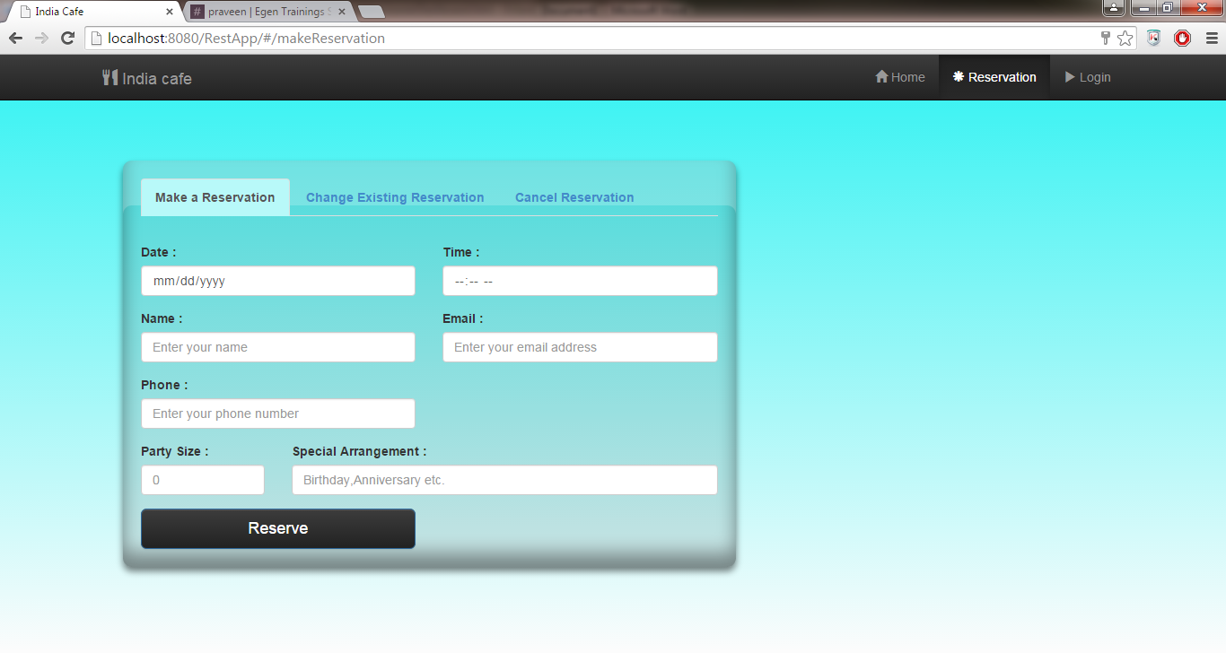

* 1. Make a Reservation: Customer creates new reservation and receives Confirmation details like Confirmation code and Table no.

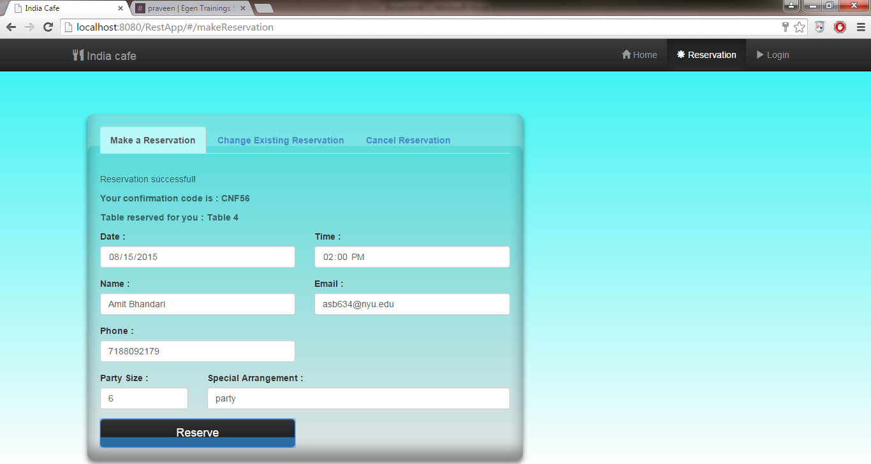

* 1. Change Existing Reservation : Customer edits existing reservation using email address and Confirmation code

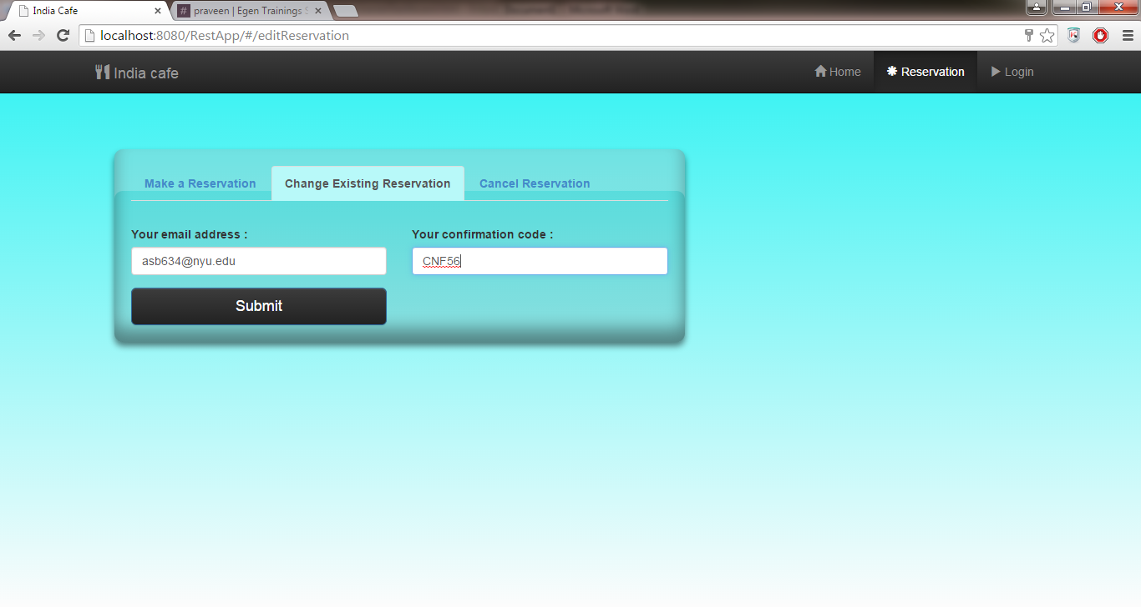

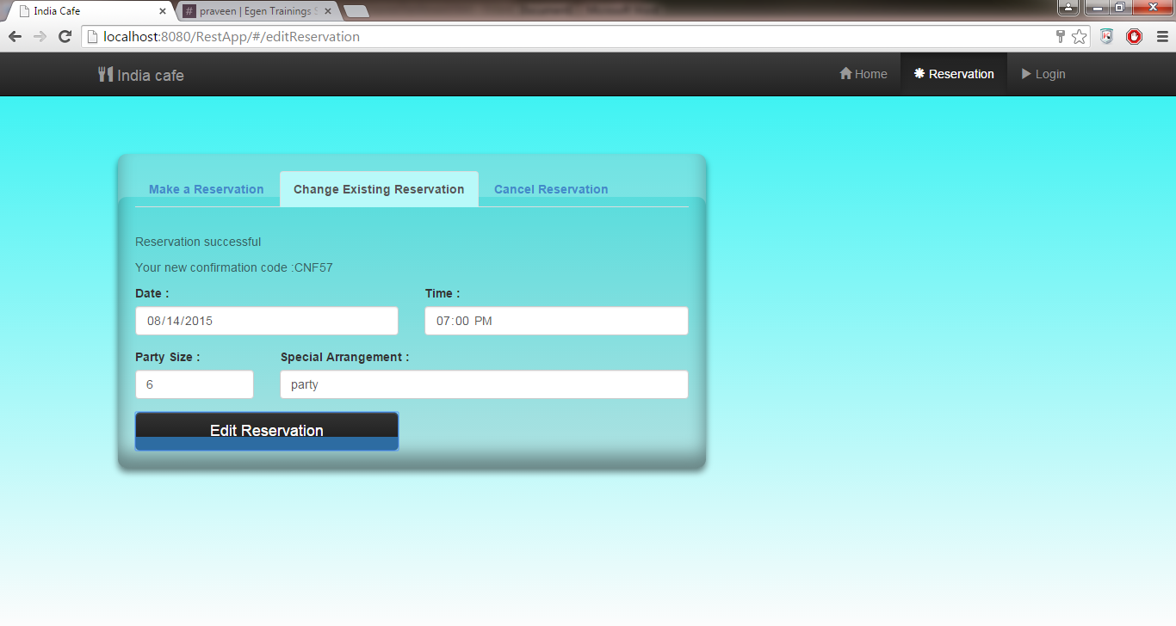

* 1. Cancel Reservation : Customer can cancel reservation

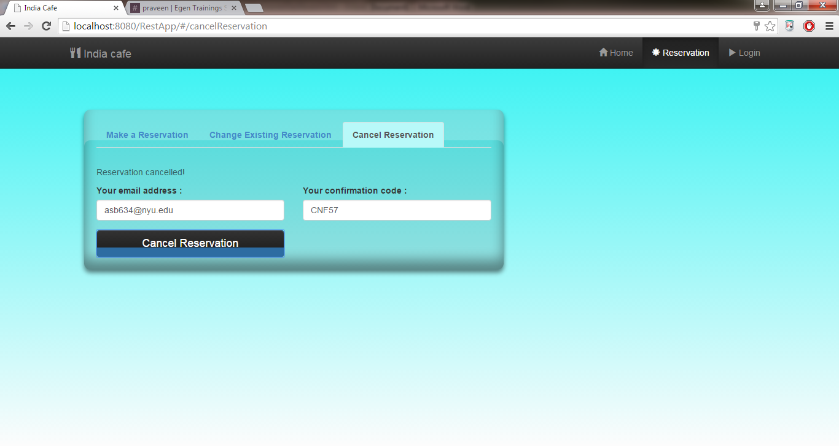

1. **Login Page :** 
   1. Implemented a functionality to authenticate the owner.
   2. Fields are validated using Angular validation.
   3. If user authenticated, navigates to Owner dashboard page or error is generated.
   4. If user authenticated, Owner profile is fetched and stored in factory to be shared with controller on Owner profile page.

**Credentials :**

Username :asb634@nyu.edu

Password : New_pass1

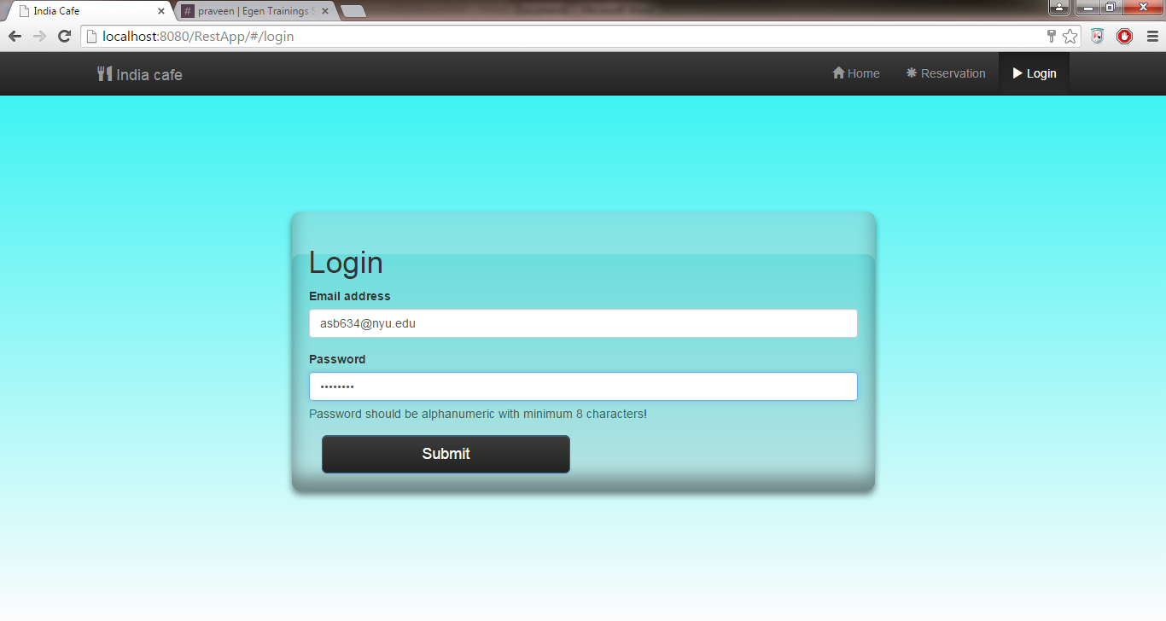

1. **Owner Dashboard :**
   1. **Owner Profile page:**
      1. Owner can change his profile details on this page
      2. On page load fetches data from factory and binds to the fields.
      3. Fields are validated using Angular validation.

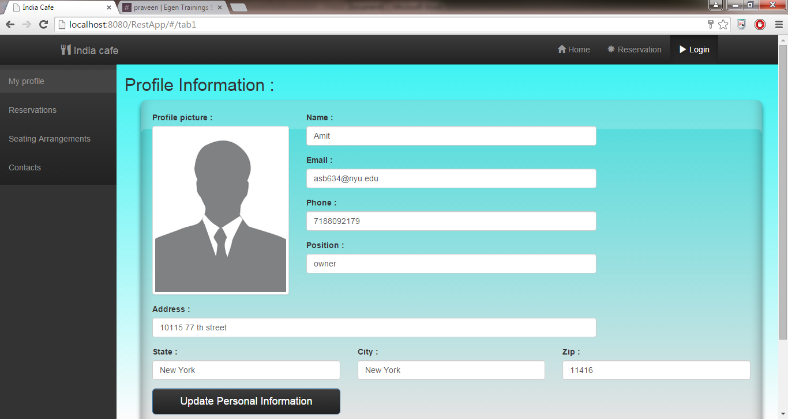

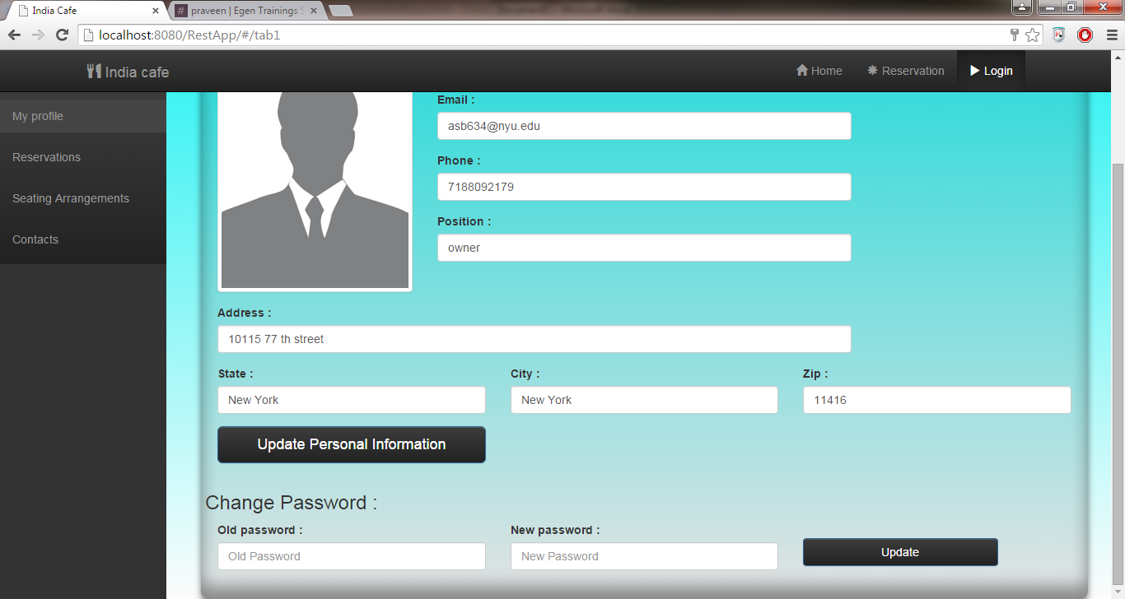

* 1. **Reservation Details :**
     1. Loads reservation details into the page
     2. Reservation data is displayed using external angular library which inherits ng-repeat to display data in tabular format as well as to paginate
     3. User can search for specific reservations.
     4. Clicking on details generates an overlay where owner can edit or cancel specific reservation

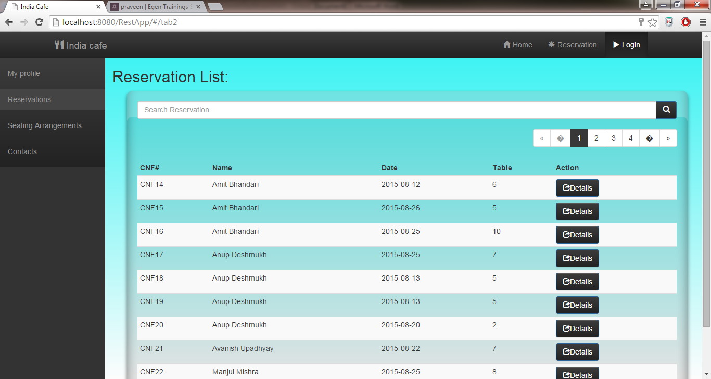

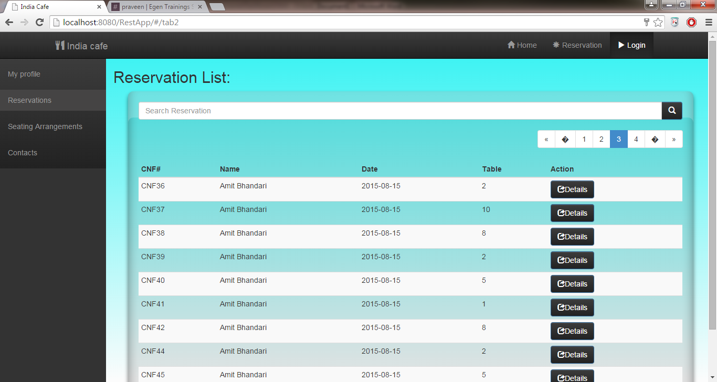

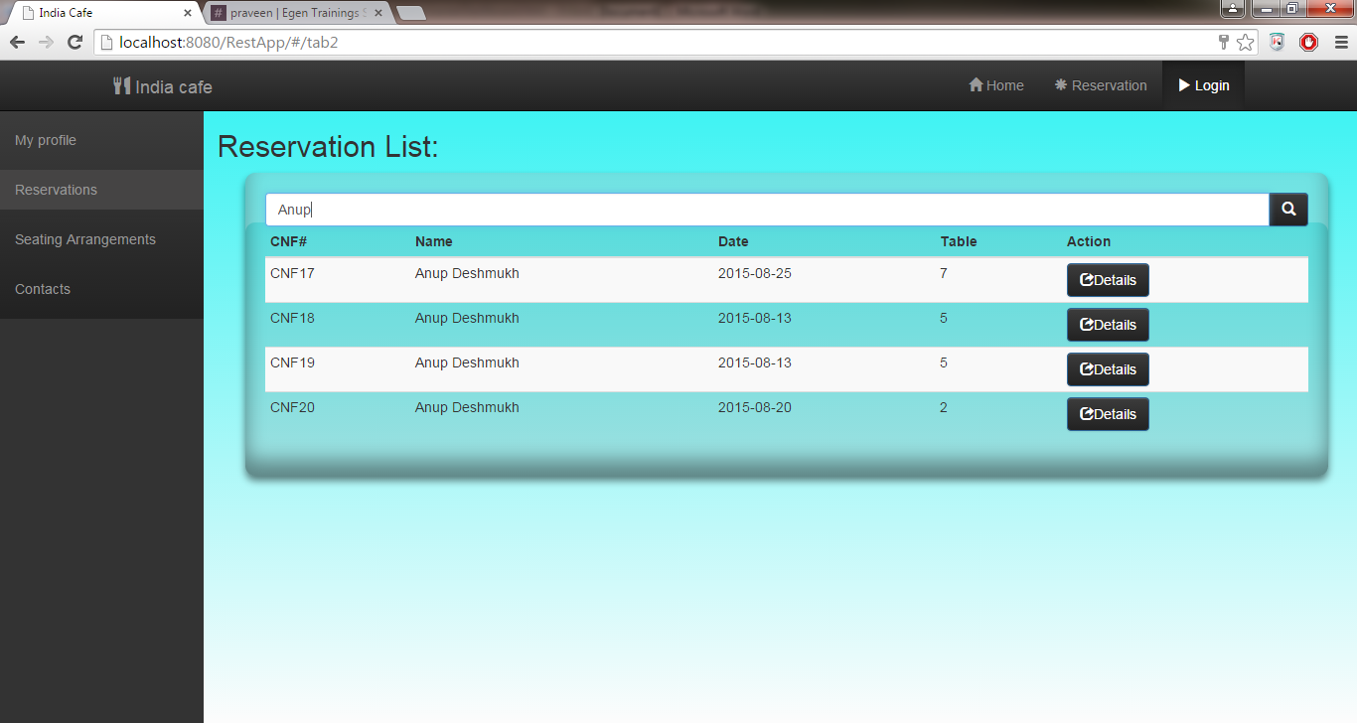

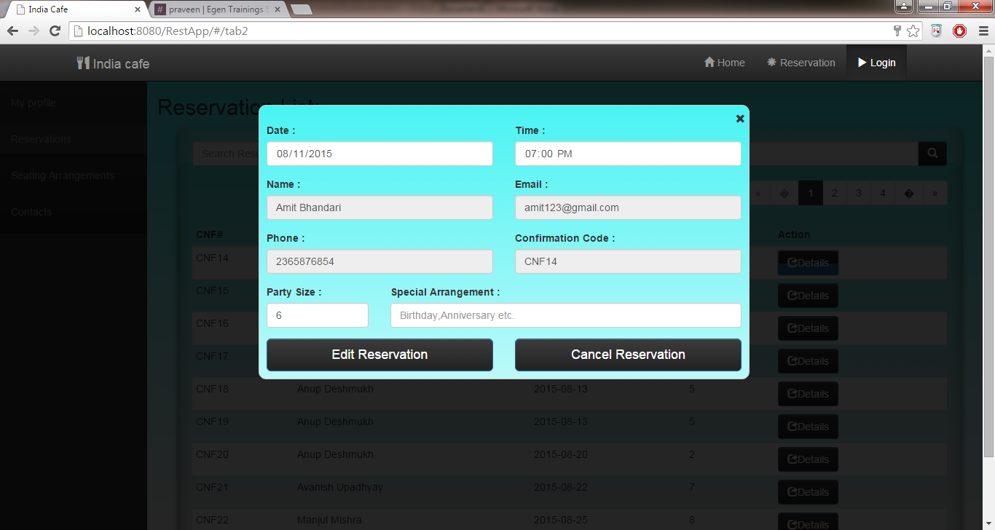

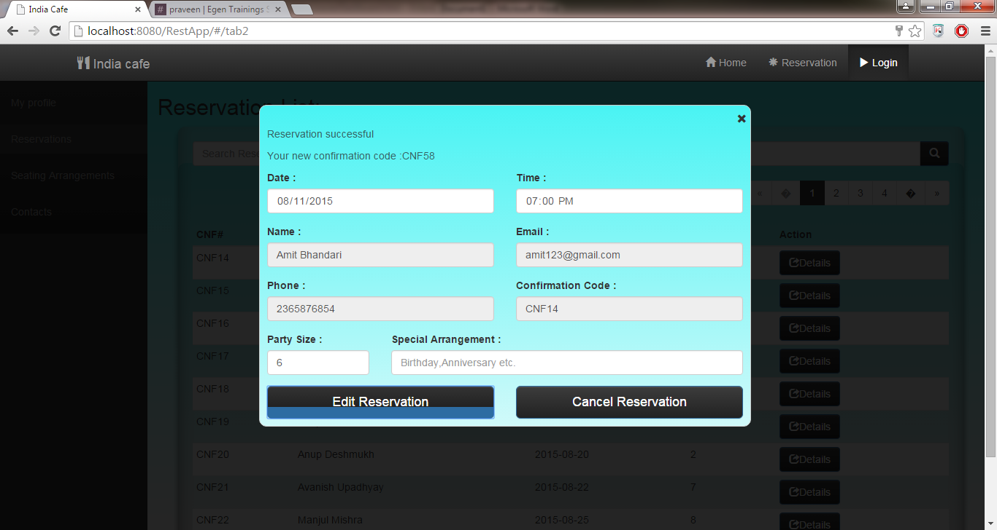

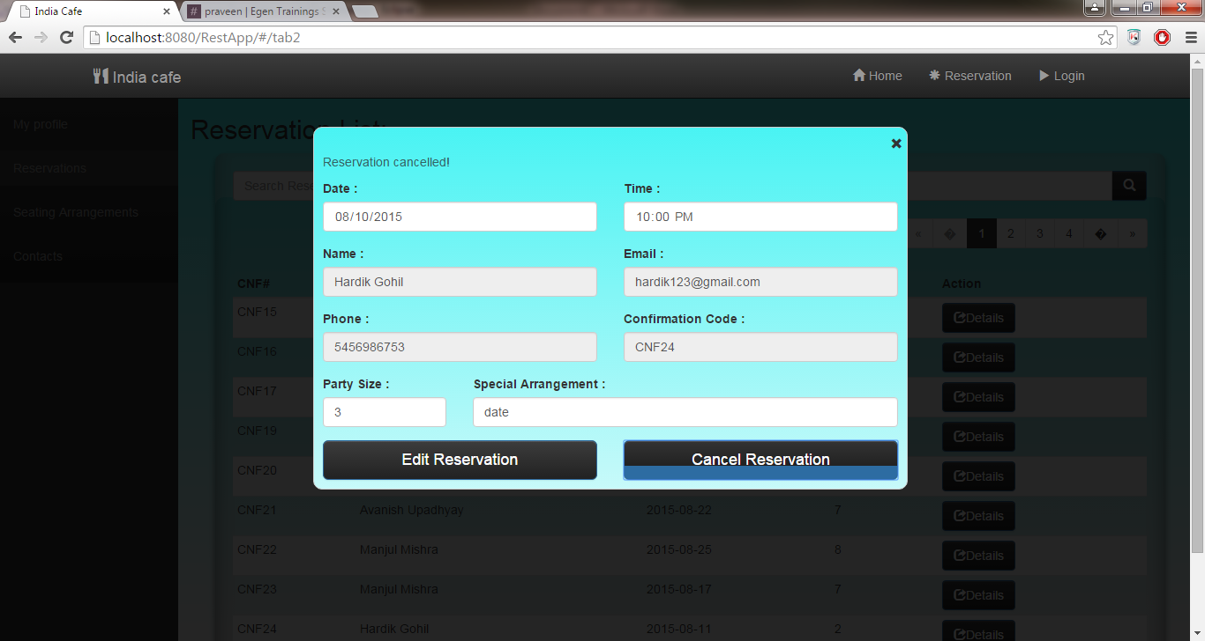

* 1. **Seating Arrangement**
     1. User has to enter date and time to search for state of seating arrangement at that time in restaurant .
     2. Seating arrangement and status of each table is displayed accordingly
     3. For particular table , user can add, edit or cancel the reservation.

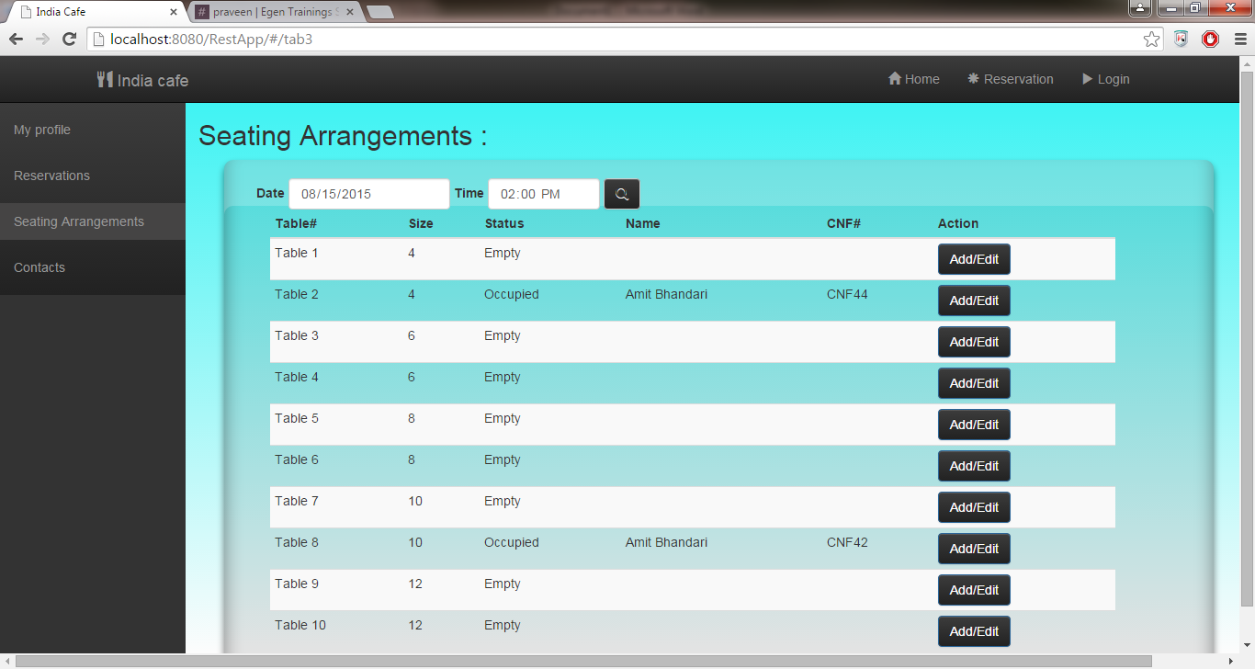

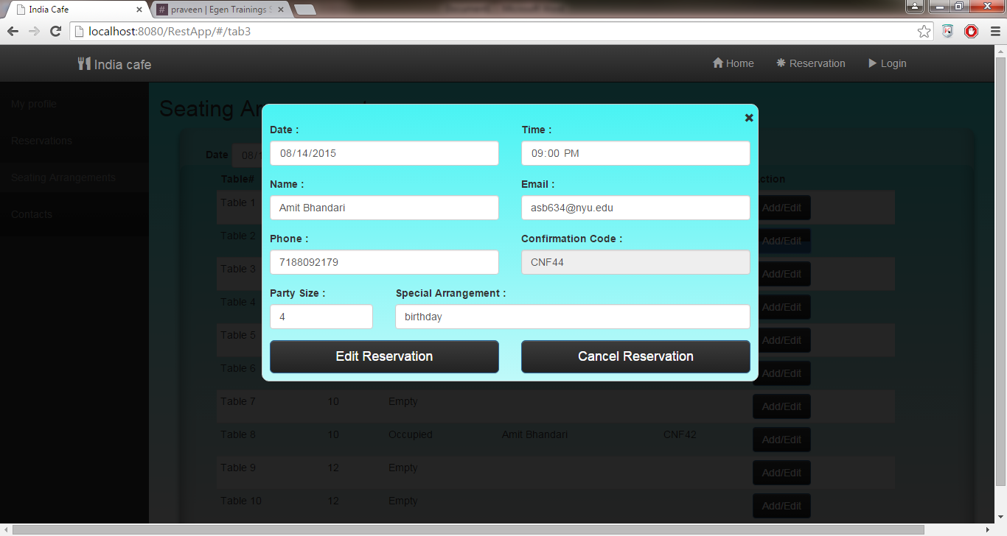

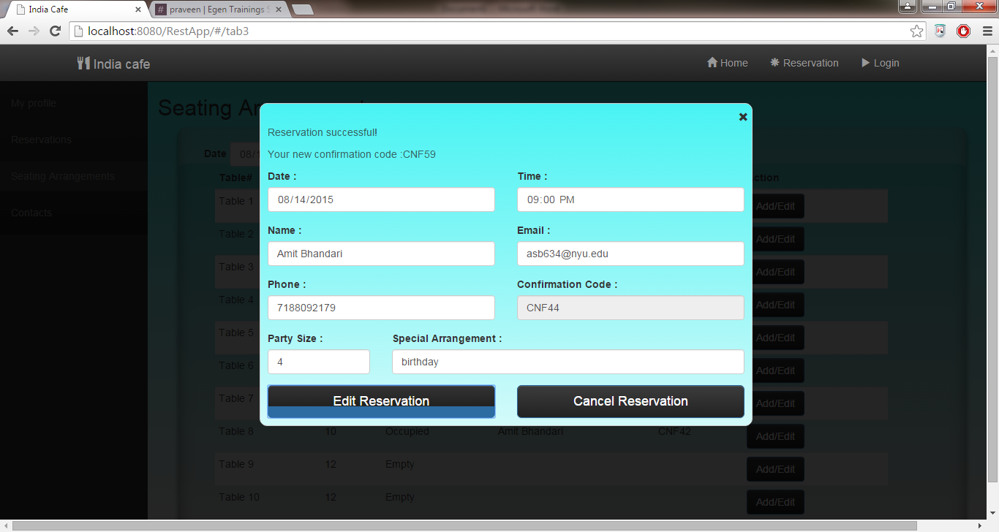

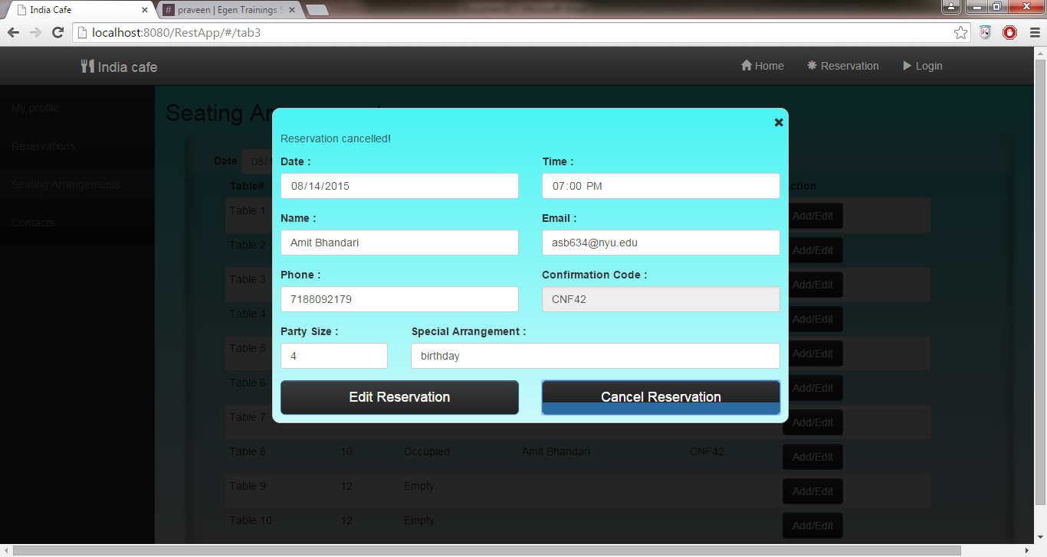

* 1. **Customer Contacts** 
     1. List of all the customers who have reserved a seat in the restaurant

